**Exploring the Restaurant scenario in the Neighbourhood of Tirupathi**

Sree Ramakrishna Patanjali Molugu

May 17, 2018

1. **Introduction**
   1. **Background**

In this project we will put efforts in analysing the restaurant scenario based on the location and cuisines located in the temple city Tirupathi .Tirupathi is India’s top pilgrimage centre and has a floating population averaging from 55,000 to 1,00,000 everyday. There are various types of restaurants catering to the needs of the floating population. Most of the restaurants are clustered around the places where likelihood of foot fall is high (Temples, Pilgrim complexes, Travel complexes etc). Urban population has a very little choice for food options in the city, as most of the restaurants in the city are of Standard Indian Cuisine Keeping in the mind to cater to the needs of Pilgrims. In this project we will try to propose various categories of restaurants around a defined central location, based on the ratings, price range and distance from the central location of the City. We will fetch the data from Foursquare API and Zomato API ‘s and analyse the data .We will also plot various Interactive maps which will help understand the dynamics of a restaurants profile.

* 1. **Target Audience**

Entrepreneurs interested in investing in the business of Food & Beverages in Tirupati will benefit in understanding the different dimensions to be factored in while setting up business. We can recommend stakeholders by exploring the neighbourhoods based on the ratings, price range and proximity for each categories. We can recommend which category of Restaurant will stand out uniquely in the city.

We will use the data science tools and techniques to understand or weigh in the pros and cons of a location. We provide an analysis for the stakeholders to take a data driven decision to choose the best category/location/price range in the city about most promising and viable option.

1. **Data Acquisition and Cleaning**
   1. **Data Sources**

We have sourced data using APIs to fetch various venues scattered around the city of Tirupathi within radius of 20 kms. We have used Foursquare API to fetch various venues irrespective of category. Using Zomato API, we have fetched all the restaurants located around 3 km radius of each of the venues and collected the restaurant names, cuisines, locations, rating and average price of restaurants.

**2.2 Data Description**

From Foursquare API (<https://api.foursquare.com/v2/venues/>) , I retrieved the following for each venue:

* **Name:** The name of the venue.
* **Category:** The category type as defined by the API.
* **Latitude:** The latitude value of the venue.
* **Longitude:** The longitude value of the venue.

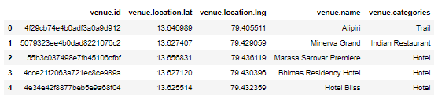

From Zomato API (<https://developers.zomato.com/api>), I retrieved the following for each venue:

* **Venue Name:** The name of the venue.
* **Address:** The complete address of the venue.
* **Rating:** The ratings as provided by many users.
* **Price range:** The price range the venue belongs to as defined by Zomato.
* **Price for two:** The average cost for two people dining at the place. I later convert the same to average price per person by dividing by 2.
* **Latitude:** The latitude value of the venue.
* **Longitude:** The longitude value of the venue.
* **Cuisines:** Cusines of the venue

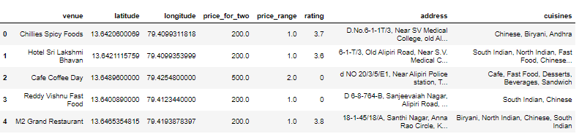

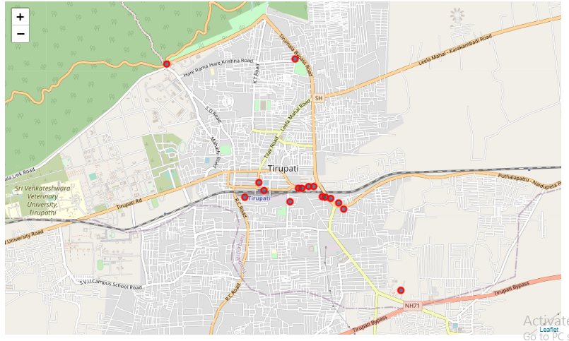

Figure :Venues fetched from Foursquare API

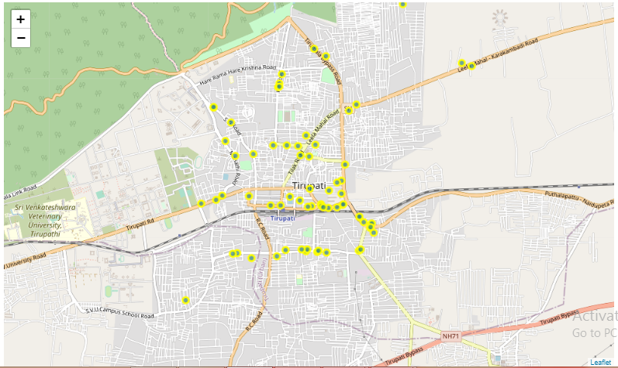

Figure :Restaurant venues fetched from Zomato API

* 1. **Data Cleaning**

Extracted Restaurant venues resulted in 419 venues. We have discovered from the data collected that there are many duplicate venues and venues from other cities. We have dropped the duplicates and filtered out the restaurants by the city name ‘Tirupati’ from the address. Final dataset has 80 restaurants from the city Tirupati without any redundant data.